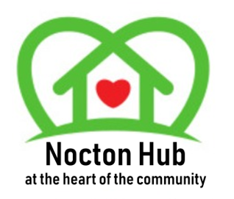
NOCTON HUB NEEDS YOU
Nocton Hub Management Group
Has vacancies for
Secretary
And
Media/PR Roles
Do you have a couple of hours spare each month to support your community building
For more information please contact
Manager_noctonhub@noctonparishcouncil.gov.uk

